**Practice Project 3: Conditional Statements**

This practice project will help you to master how to write automation code in Python to make decisions in different situations. You will see how intelligent real-world applications are created.

1. What Boolean value does each expression below produce? Figure out the answer before you verify your answer by running the expression in Python
   1. True and False = False
   2. True and false (notice the capitalization) : Error
   3. True and not False = True
   4. True or True and False = False
   5. not False or True = True
   6. not False or not True = True
   7. not 2 =False
   8. not 0 = True
   9. not []= True # check for if it is not a list
   10. True and not 0 = True
   11. 5.5 < 5.6 = True
2. Write a program that will turn on the heat when the temperature is below 50 degrees Fahrenheit.
   1. Collect the temperature from a user and assign the temperature value to a variable called **temperature**.
   2. Write an if statement that checks the temperature, then print “it is getting too cold, turning on the heat …” if the temperature is below 50. The program should do nothing if the temperature is 50 or above. (you need just an if-statement, not an if-else statement).

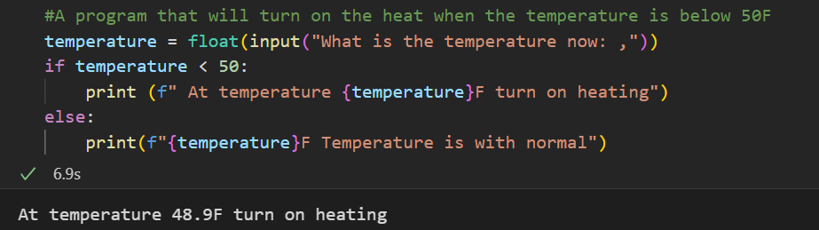

50.0F Temperature is with normal

1. Write an if/else statement that checks whether two values are equivalent; if the values are the same, print “the values are the same”; otherwise, print “the values are different”. You can use the user input function to collect two values and assign them to variables **a** and **b**. You could also assign any two values directly to **a** and **b** without using a user input function.

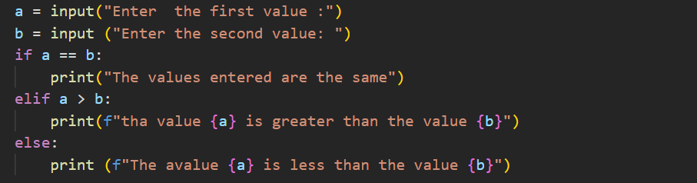

1. Write a program that detects whether some solution is acidic or alkali. Collect the pH level of the solution from a user and assign it to a variable, **ph**. Note that Acidic solutions have a pH less than 7 and alkali solutions have a pH greater than 7. The program should print a statement to the user about whether the solution is acidic or alkali. Test the program using pH levels of 7, 12, and 4.

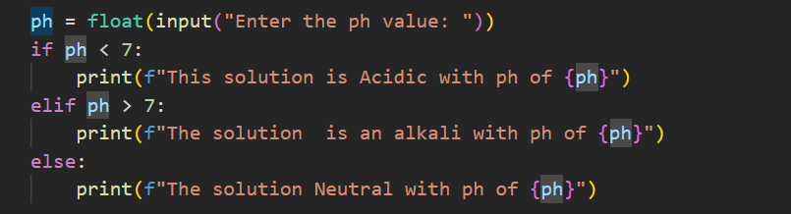

1. Now you will extend the pH program above to detect whether a solution is neutral, a weak acidic, strong acidic, weak alkali or strong alkali. Use the information in this table to write your code. Your code should check the pH level collected from a user and print the type of solution corresponding to the pH level.

|  |  |
| --- | --- |
| pH Level | Type of Solution |
| 0 to 2 | Strong acid |
| 3 to 6 | Weak acid |
| 7 | Neutral |
| 8 to 11 | Weak alkali |
| 12 to 14 | Strong alkali |

Test your program using pH levels, 1, 4, 5, 7, 10, 13.

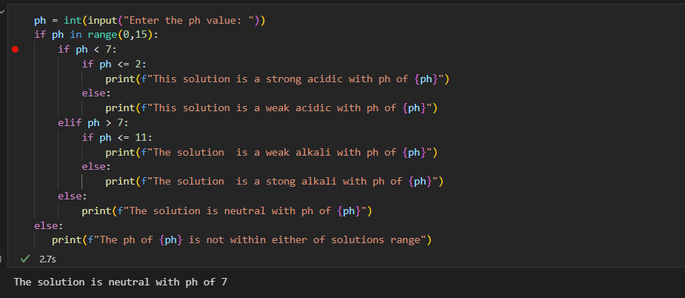

1. Ask a user whether they want to buy oranges or apples. Assign the value they provide in a variable called **fruit_type.** The price for one orange is 1.5 dollars while one apple costs 2 dollars. Then ask the user how many fruits they want to buy. Assign the value collected into a variable called quantity. Your program should then use conditional statement to check the type of fruit, calculate the how much the user will pay and print the price of the fruits to them. Your print statement should read something like, “5 apples will cost you 10 dollars”. Do not hard code the values into the print statement but use variables to plug in the values into the print statement. Test your program using “apple and 10”, then “oranges and 10” as inputs or values for the fruit type and quantity.

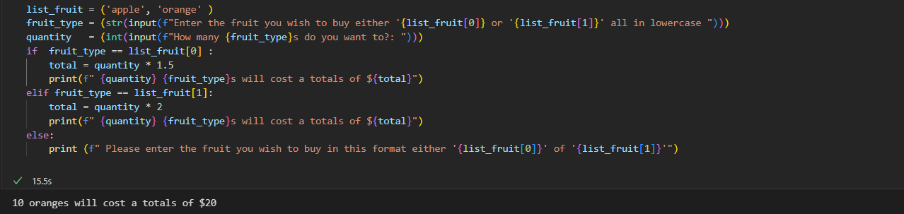

1. Write a program that suggests how much tips should be given to the server in the restaurant. Customers should pay 15% of their bill as tips if their bill is below 25 dollars and should pay 10% of the bill as tips if the bill is 25 dollars or above.

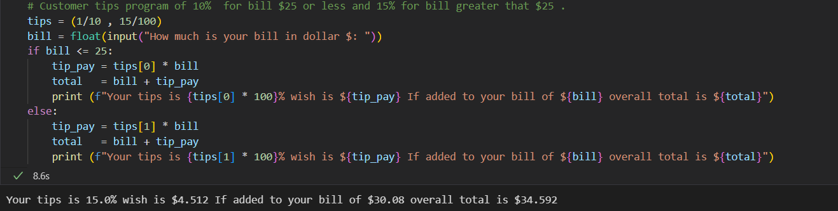

1. A professor has given three tests to students and wants but only the two best scores will be used to compute the average for that course. Write a program that takes three scores, then selects two of the best scores, calculates the average score, and checks whether the average score is above 75. If the average value of the two best two scores is above 75, print “pass”; otherwise, tell the students to take an additional assignment. (Hint, you can collect three values using the input function, then append each value you collect to a list, so you need to create an empty list and then append values to it. Sort the values and extract the first to, then use the sum and len functions to compute the average. This problem can also be solved with for loops, but we have not covered loops so just manually write the code to collect the three values and append to the list.)
2. Write a program that collects a point grade between 0 and 100 (inclusive) and print the letter grade. Use the following grading scheme to produce the appropriate letter grade.

|  |  |
| --- | --- |
| Range of Point-Grade | Letter Grade |
| 90 – 100 | A |
| 80 – 89.99 | B |
| 70 – 79.99 | C |
| 60 – 69.99 | D |
| 0 – 59.99 | F |

Ensure the program prints an error message when the wrong input is entered (for example, the program should not take numbers below 0 or above 100. Test the program with text, numbers greater than 100, and a negative number to make sure it is working well. Then test the program with the right input values such as 50, 60, 72, 89, 98, 102, and -7.

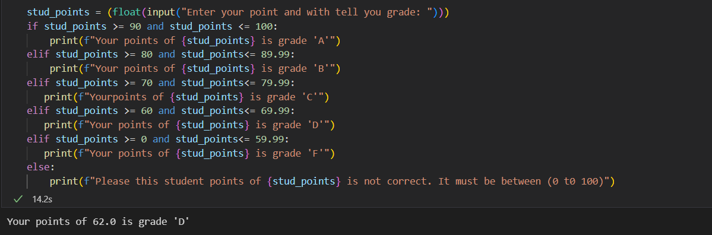

Your points of 50.0 is grade 'F'

Your points of 72.0 is grade 'C'

Your points of 89.0 is grade 'B'

Your points of 98.0 is grade 'A'

Please this student points of 102.0 is not correct. It must be between (0 t0 100)

Please this student points of -7.0 is not correct. It must be between (0 t0 100)

1. Find a problem of your choice that requires you to use a conditional statement and solve it with a python program. Describe what your program is doing.